Scrum Master Report:

Dates: 04/09/23 - 10/09/23

Scrum Master:  Pyper McCreanor-Rupe.

Participants:  Maki, Jethro, Gray, Charles, Ciar and Pyper.

Meeting Notes for Planning:

* Date: 05/09/23
* Sprint goals:
  + The codebase for the initial phase of the web app's development was uploaded to GitHub and later merged into the main branch. We held our weekly team meeting to allocate tasks among team members. This week we will continue working through the project on our respective tasks and aim to have it done by our next team meeting on Friday.

* This is how our Kanban is currently looking at the beginning of this week. We have completed 9 tasks from the previous iteration and have 4 tasks we aim to finish by the end of this iteration.

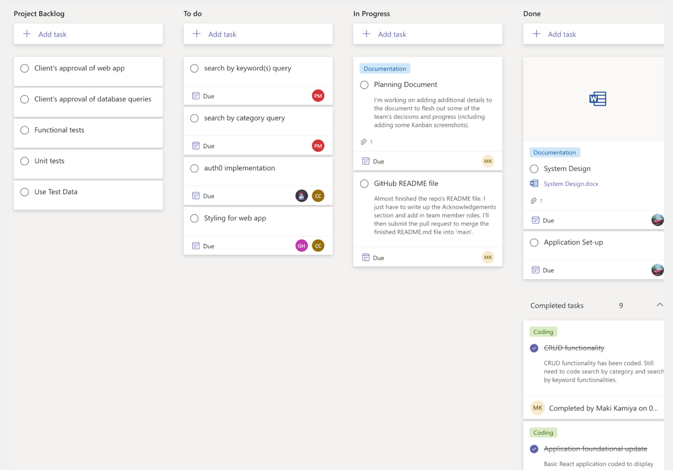

Progress Updates throughout the Sprint:

* Date: 10/09/23
* Everyone continued working on their tasks throughout the week and updating the team through our team's channel.

Retrospective Notes:

* Date:  11/09/23
* Participants:  Maki, Jethro, Gray, Charles, Ciar and Pyper.

By the end of this iteration, this is our updated Kanban board. We have completed 14 tasks in total so far for this project. The Kanban board has now been updated with tasks assigned to individual team members ready for the testing part of the project.

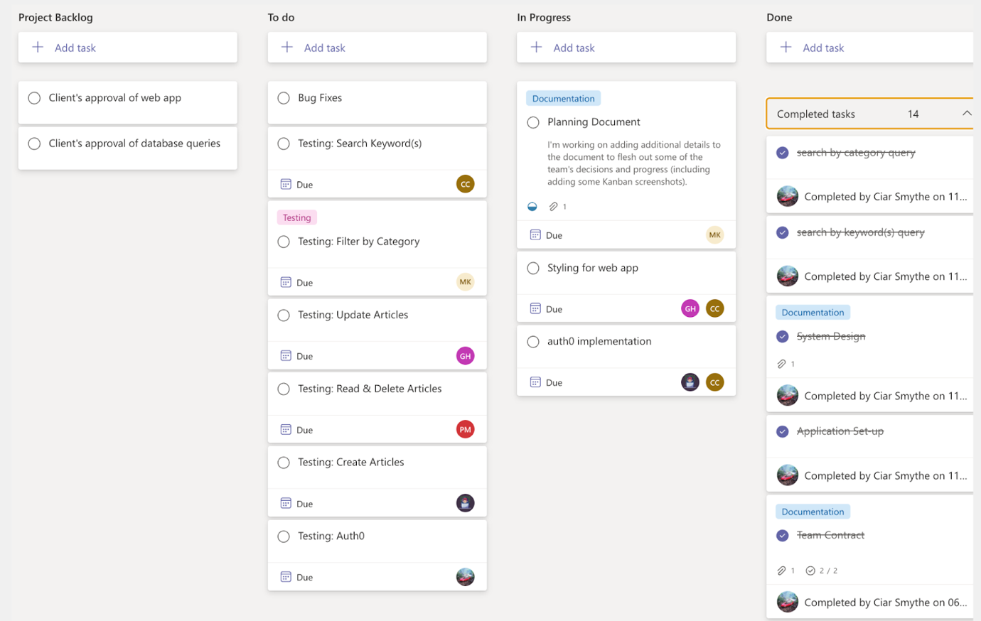

Accomplished:

* This week we made great progress in the project ticking a few of the tasks off such as GitHub repo, database, documentation, CRUD functionalities and search and filtering functionalities.

Not accomplished:

* There are a few things that are yet to be completed such as the authentication and authorization features and the CSS.

What went well?

* This week the team communicated well as always, continuing to update the team's channel. We did not have an end-of-week call on Friday due to the unavailability of team members, however, it has been postponed till Monday.

Action items for the next sprint:

* We are now moving on to the testing phase of our project, we have decided to divide tasks among team members. During this testing cycle, each team member has been allocated different tasks to test. This division of tasks enables us to thoroughly evaluate all areas of our application, assuring a more reliable evaluation. We have created a testing document to help us maintain a planned and organised approach to our testing activities. Each team member will write up a summary of their results and observations in this document. This summary will include the user story they followed, what went well, what went wrong, and any issues or improvements discovered during the testing process. This week everyone will work on their individual tasks, and we will have a final meeting before we hand in the project on Friday.